# **UNIVERSITAS GUNADARMA**

# **PRAKTIKUM PEMROGRAMAN WEB**



**MANUAL BOOK**

“Dream Station”

Nama Anggota :

1. Dimas Arya Sauki A. (50422428)
2. Muhamad Zidan Indratama (50422968)

Kelas : 3IA08

Fakultas : Teknologi Industri

Jurusan : Teknik Informatika

PJ : Muhammad Rizqi Fajri

**Ditulis Guna Melengkapi Sebagian Syarat**

**Praktikum Pemrograaman Web**

**Universitas Gunadarma**

**2025**

# **DAFTAR ISI**

**UNIVERSITAS GUNADARMA** 1

**PRAKTIKUM PEMROGRAMAN WEB** 1

**DAFTAR ISI** 2

**BAB I** 3

**PENDAHULUAN** 3

**1.1 Latar Belakang** 3

**1.2 Tujuan** 3

**BAB II** 5

**PEMBAHASAN** 5

**2.1 Tahapan Pembuatan Website Dream Station** 5

**2.2 Alur Kerja Website** 6

**2.3 Fitur Utama** 6

**2.4 Keunggulan Teknologi** 6

**BAB III** 7

**ANALISA DAN PERANCANGAN** 7

**3.1 Frontend** 7

**3.2 Backend** 33

**3.3 Output** 41

**3.4 Link** 45

**BAB IV** 46

**PENUTUP** 46

**4.1 Kesimpulan** 46

**4.2 Saran** 46

# **BAB I**

## **PENDAHULUAN**

### **1.1 Latar Belakang**

Dalam kehidupan, setiap individu memiliki mimpi atau cita-cita yang menjadi pendorong semangat untuk mencapai tujuan hidup. Namun, seringkali mimpi-mimpi tersebut terlupakan atau kehilangan daya dorong akibat rutinitas dan tantangan yang dihadapi sehari-hari. Oleh karena itu, diperlukan suatu media yang dapat menjadi wadah untuk mencatat, mengingat, dan membagikan mimpi-mimpi tersebut agar semangat untuk mewujudkannya tetap terjaga.

Website ini dirancang sebagai platform di mana pengguna dapat menuliskan mimpi-mimpi mereka. Dengan fitur yang memungkinkan orang lain untuk melihat mimpi yang telah dibagikan, website ini juga menjadi sumber inspirasi dan motivasi. Melalui konsep berbagi mimpi ini, diharapkan tercipta komunitas yang saling mendukung dan memotivasi untuk terus berusaha mencapai tujuan masing-masing.

Proyek ini dikembangkan menggunakan teknologi modern yang membagi pengembangan menjadi dua sisi: frontend dan backend.

* Frontend: Dibangun menggunakan TypeScript, NextJS, TailwindCSS, ShadcnUI, Lucide Icon, React Hook Form, React Query, Axios, dan Zod.
* Backend: Dibangun menggunakan TypeScript, NestJS, Cloudinary, Prisma, dan MongoDB.

Dengan memanfaatkan teknologi-teknologi tersebut, website ini diharapkan dapat memberikan pengalaman pengguna yang intuitif, responsif, dan aman.

### **1.2 Tujuan**

Dalam Tujuan kami dalam membuat situs web Dream Station ini adalah:

1. Mencatat dan Mengingatkan:

Menyediakan wadah bagi pengguna untuk mencatat dan mengingat mimpi-mimpi mereka, sehingga tidak terlupakan di tengah kesibukan sehari-hari.

1. Membangun Komunitas Inspiratif:

Membentuk komunitas yang saling mendukung dan memotivasi melalui berbagi mimpi.

1. Meningkatkan Semangat dan Motivasi:

Memberikan inspirasi kepada pengguna lain dengan melihat mimpi-mimpi yang telah dibagikan.

1. Mendukung Teknologi Modern:

Menerapkan teknologi terkini dalam pengembangan untuk memastikan performa, keamanan, dan kenyamanan pengguna.

1. Menyediakan Platform yang User-Friendly:

Menghadirkan antarmuka yang sederhana, responsif, dan mudah digunakan oleh semua kalangan.

# **BAB II**

## **PEMBAHASAN**

### **2.1 Tahapan Pembuatan Website Dream Station**

Website ini dibangun dengan memanfaatkan teknologi modern yang dibagi menjadi dua bagian utama, yaitu frontend dan backend:

#### **2.1.1 Frontend**

Frontend merupakan bagian antarmuka pengguna yang bertanggung jawab atas tampilan dan interaksi pengguna. Teknologi yang digunakan meliputi:

* TypeScript: Bahasa pemrograman yang memperluas JavaScript dengan tipe data statis.
* NextJS: Framework React yang mendukung server-side rendering dan static site generation.
* TailwindCSS: Framework CSS yang mempermudah styling dengan pendekatan utility-first.
* ShadcnUI: Library UI untuk membuat antarmuka yang modern dan konsisten.
* Lucide Icon: Library ikon yang ringan dan mudah digunakan.
* React Hook Form: Library untuk pengelolaan formulir yang efisien dan fleksibel.
* React Query: Library untuk pengelolaan data asynchronous.
* Axios: Library untuk melakukan HTTP request.
* Zod: Library validasi schema untuk memastikan data yang diterima sesuai dengan format yang diharapkan.

#### **2.1.2 Backend**

Backend bertanggung jawab atas logika bisnis dan pengelolaan data. Teknologi yang digunakan meliputi:

* TypeScript: Untuk memastikan kode yang lebih aman dan dapat diprediksi.
* NestJS: Framework backend yang modular dan mendukung pengembangan yang terstruktur.
* Cloudinary: Layanan penyimpanan dan pengelolaan media.
* Prisma: ORM untuk pengelolaan database.
* MongoDB: Database NoSQL yang fleksibel dan skalabel.

### **2.2 Alur Kerja Website**

* Pengguna Menulis Mimpi: Pengguna dapat menulis dan menyimpan mimpi mereka melalui formulir yang telah disediakan.
* Penyimpanan Data: Mimpi yang ditulis pengguna akan disimpan dalam database MongoDB melalui backend yang telah dikembangkan.
* Menampilkan Mimpi: Mimpi-mimpi yang telah disimpan akan ditampilkan di halaman utama website untuk dilihat oleh pengguna lain.
* Berbagi Motivasi: Dengan melihat mimpi-mimpi orang lain, pengguna dapat saling memberikan inspirasi dan motivasi.

### **2.3 Fitur Utama**

* Pencatatan Mimpi: Fitur untuk mencatat dan menyimpan mimpi pengguna.
* Berbagi Mimpi: Fitur untuk menampilkan mimpi yang telah dibagikan oleh pengguna lain.
* Pengelolaan Media: Integrasi dengan Cloudinary untuk mengelola gambar atau media lain yang terkait dengan mimpi.
* Validasi Data: Validasi input pengguna menggunakan Zod untuk memastikan data yang disimpan valid.

### **2.4 Keunggulan Teknologi**

* Responsif dan Cepat: Menggunakan NextJS dan TailwindCSS untuk memastikan performa yang optimal di berbagai perangkat.
* Keamanan Data: Dengan Prisma dan validasi berbasis schema, data pengguna terlindungi.
* Pengalaman Pengguna yang Intuitif: Antarmuka dirancang agar mudah digunakan bahkan oleh pengguna awam.
* Pengelolaan Media yang Efisien: Cloudinary memastikan media dikelola dengan baik dan dapat diakses dengan cepat.

Dengan pembahasan ini, diharapkan pengguna memahami bagaimana platform ini bekerja serta keunggulan yang ditawarkan.

# **BAB III**

## **ANALISA DAN PERANCANGAN**

### **3.1 Frontend**

#### **3.1.1 Instalasi Project**

Instalasi project adalah langkah awal untuk mempersiapkan lingkungan pengembangan yang sesuai dengan kebutuhan. Pada bagian ini, akan dijelaskan cara mengatur dependensi dan konfigurasi awal project.

* Instalasi NextJS

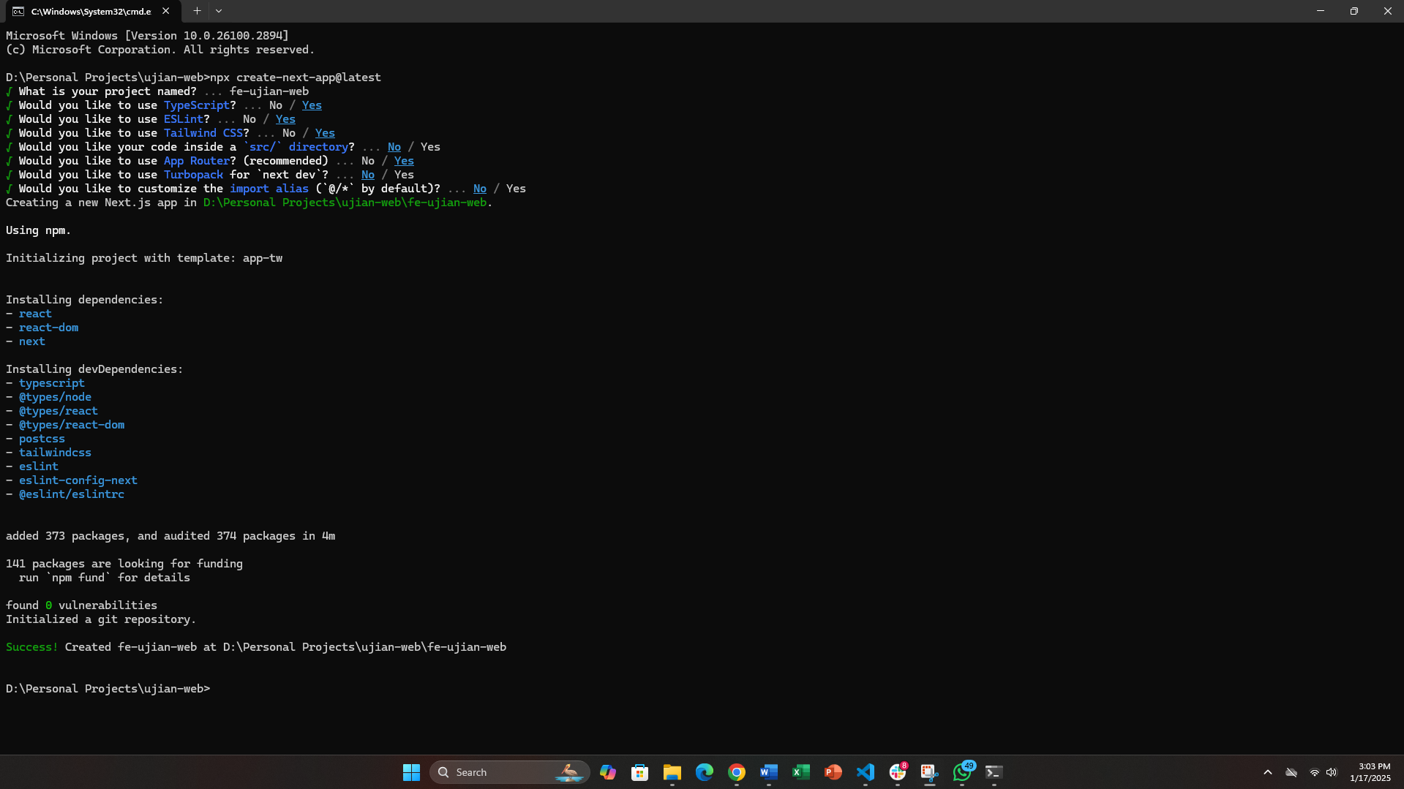

* Instalasi React Query



* Instalasi Zod dan React Hook Form



#### **3.1.2 Providers**

Providers adalah komponen yang berfungsi menyediakan konteks atau layanan tertentu ke dalam aplikasi. Penjelasan ini mencakup pengaturan dan penggunaannya di dalam project.

* Tanstack Query Provider

|  |
| --- |
| "use client";  **import** { **QueryClient**, **QueryClientProvider** } **from** "@tanstack/react-query";  **import** { **ReactQueryDevtools** } **from** "@tanstack/react-query-devtools";  **import** **React** **from** "react";  **const** **TanStackProvider** = ({ children }: { children: React.ReactNode }) => {  **const** queryClient = **new** **QueryClient**();  **return** (  <**QueryClientProvider** client={queryClient}>  {children}  <**ReactQueryDevtools** initialIsOpen={false} />  </**QueryClientProvider**>  );  };  **export** **default** **TanStackProvider**; |

* Theme Provider

|  |
| --- |
| "use client";  **import** * **as** **React** **from** "react";  **import** { **ThemeProvider** **as** **NextThemesProvider** } **from** "next-themes";  **export** **function** **ThemeProvider**({  children,  ...props  }: React.ComponentProps<**typeof** NextThemesProvider>) {  **return** <**NextThemesProvider** {...props}>{children}</**NextThemesProvider**>;  } |

#### **3.1.3 Types**

Types merujuk pada tipe data yang digunakan dalam pengembangan. Bagian ini menjelaskan definisi tipe-tipe data untuk memastikan konsistensi dan keandalan dalam kode.

* TBenefit

|  |
| --- |
| **import** { **IconType** } **from** "react-icons/lib";  **export** **type** **TBenefit** = {  id: string;  icon: **IconType**;  title: string;  description: string;  }; |

* TDream

|  |
| --- |
| **export** **type** **TDream** = {  id: string;  username: string;  title: string;  slug: string;  description: string;  image: string;  createdAt: string;  updatedAt: string;  }; |

* TNavigation

|  |
| --- |
| **export** **type** **TNavigation** = {  id: string;  label: string;  href: string;  }; |

* TSocial

|  |
| --- |
| **import** { **IconType** } **from** "react-icons/lib";  **export** **type** **TSocial** = {  id: string;  icon: **IconType**;  label: string;  href: string;  }; |

* TTeam

|  |
| --- |
| **export** **type** **TTeam** = {  id: string;  name: string;  bio: string;  photo: string;  link: string;  }; |

* TTech

|  |
| --- |
| **import** { **IconType** } **from** "react-icons/lib";  **export** **type** **TTech** = {  name: string;  icon: **IconType**;  }; |

* TTestimonial

|  |
| --- |
| **export** **type** **TTestimonial** = {  id: string;  image: string;  name: string;  job: string;  description: string;  }; |

#### **3.1.4 Mock Data**

Mock data digunakan untuk pengujian dan pengembangan fitur. Pada bagian ini, akan dijelaskan bagaimana data dummy dibuat dan dimanfaatkan dalam pengembangan.

* benefitData

|  |
| --- |
| **import** { **TBenefit** } **from** "@/types/benefit.type";  **import** { **FaLightbulb**, **FaUsers**, **FaRocket**, **FaChartLine** } **from** "react-icons/fa";  **export** **const** benefitData: **TBenefit**[] = [  {  id: "1",  icon: **FaLightbulb**,  title: "Unlock New Perspectives",  description:  "Sharing your dreams can spark fresh ideas and innovative solutions that you may have never considered before.",  },  {  id: "2",  icon: **FaUsers**,  title: "Connect with Like-Minded People",  description:  "Build meaningful relationships with individuals who share your aspirations and are eager to support your journey.",  },  {  id: "3",  icon: **FaRocket**,  title: "Take the First Step Forward",  description:  "Expressing your dreams is the first step toward turning them into actionable plans and achieving your goals.",  },  {  id: "4",  icon: **FaChartLine**,  title: "Track Your Progress",  description:  "Documenting your dreams helps you measure your growth and stay motivated as you move closer to your aspirations.",  },  ]; |

* navigationData

|  |
| --- |
| **import** { **TNavigation** } **from** "@/types/navigation.type";  **export** **const** navigationData: **TNavigation**[] = [  {  id: "1",  label: "Home",  href: "/",  },  {  id: "2",  label: "About Us",  href: "/about-us",  },  {  id: "3",  label: "Dreams",  href: "/dreams",  },  ]; |

* socialData

|  |
| --- |
| **import** { **TSocial** } **from** "@/types/social.type";  **import** { **SiNestjs**, **SiNextdotjs** } **from** "react-icons/si";  **export** **const** socialData: **TSocial**[] = [  {  id: "1",  icon: **SiNextdotjs**,  label: "Repo GitHub Frontend",  href: "https://github.com/zidanindratama/ujian-pemrograman-web/tree/main/fe-ujian-pemrograman-web",  },  {  id: "2",  icon: **SiNestjs**,  label: "Repo GitHub Backend",  href: "https://github.com/zidanindratama/ujian-pemrograman-web/tree/main/be-ujian-pemrograman-web",  },  ]; |

* teamData

|  |
| --- |
| **import** { **TTeam** } **from** "@/types/team.type";  **export** **const** teamData: **TTeam**[] = [  {  id: "1",  name: "Muhamad Zidan Indratama",  bio: "Fullstack Web Developer from Bekasi with a strong track record in web design and development.",  photo: "/teams/zidan.jpg",  link: "https://www.linkedin.com/in/zidan-indratama/",  },  {  id: "2",  name: "Dimas Arya Sauki A.",  bio: "Passionate mobile app developer. Computer Science student seeking opportunities to build innovative apps.",  photo: "/teams/dimas.jpg",  link: "https://www.instagram.com/arya_dimas99/",  },  ]; |

* techData

|  |
| --- |
| **import** { **TTech** } **from** "@/types/tech.type";  **import** { **BiLogoTypescript** } **from** "react-icons/bi";  **import** { **RiNextjsFill** } **from** "react-icons/ri";  **import** {  **SiNestjs**,  **SiCloudinary**,  **SiPrisma**,  **SiMongodb**,  **SiTailwindcss**,  **SiShadcnui**,  **SiLucide**,  **SiReacthookform**,  **SiReactquery**,  **SiAxios**,  **SiZod**,  } **from** "react-icons/si";  **export** **const** backendTechData: **TTech**[] = [  {  name: "Typescript",  icon: **BiLogoTypescript**,  },  {  name: "NestJS",  icon: **SiNestjs**,  },  {  name: "Cloudinary",  icon: **SiCloudinary**,  },  {  name: "Prisma ORM",  icon: **SiPrisma**,  },  {  name: "MongoDB",  icon: **SiMongodb**,  },  ];  **export** **const** frontendTechData: **TTech**[] = [  {  name: "Typescript",  icon: **BiLogoTypescript**,  },  {  name: "NextJS",  icon: **RiNextjsFill**,  },  {  name: "Tailwind CSS",  icon: **SiTailwindcss**,  },  {  name: "ShadCN UI",  icon: **SiShadcnui**,  },  {  name: "Lucide Icon",  icon: **SiLucide**,  },  {  name: "React Hook Form",  icon: **SiReacthookform**,  },  {  name: "React Query",  icon: **SiReactquery**,  },  {  name: "Axios",  icon: **SiAxios**,  },  {  name: "Zod",  icon: **SiZod**,  },  ]; |

* testimonialData

|  |
| --- |
| **import** { **TTestimonial** } **from** "@/types/testimonial.type";  **export** **const** testimonialData: **TTestimonial**[] = [  {  id: "1",  image: "https://randomuser.me/api/portraits/men/1.jpg",  name: "Ravi Pratama",  job: "Software Engineer",  description:  "This platform helped me grow my career by connecting me with amazing mentors. The resources are insightful, and the community is incredibly supportive.",  },  {  id: "2",  image: "https://randomuser.me/api/portraits/men/2.jpg",  name: "Dwi Santoso",  job: "Product Designer",  description:  "I love how easy it is to connect with people who share the same passions. The feedback I received was invaluable for refining my design skills.",  },  {  id: "3",  image: "https://randomuser.me/api/portraits/men/3.jpg",  name: "Ari Prakoso",  job: "Digital Marketer",  description:  "The advice I got from sharing my dreams here motivated me to push harder in my marketing strategies. I feel more confident about my career path now.",  },  {  id: "4",  image: "https://randomuser.me/api/portraits/men/4.jpg",  name: "Budi Hartono",  job: "Entrepreneur",  description:  "I’ve found so many like-minded individuals who support my startup journey. This platform is a great place to receive guidance and share experiences.",  },  {  id: "5",  image: "https://randomuser.me/api/portraits/men/5.jpg",  name: "Andi Setiawan",  job: "UX/UI Designer",  description:  "As a designer, it's hard to find good advice. This community gave me the insights I needed to make my work more user-friendly and visually appealing.",  },  {  id: "6",  image: "https://randomuser.me/api/portraits/men/6.jpg",  name: "Indra Kurniawan",  job: "Software Developer",  description:  "Being part of this community made me realize the potential of my dream. The support I received was essential for overcoming obstacles in my development projects.",  },  {  id: "7",  image: "https://randomuser.me/api/portraits/men/7.jpg",  name: "Hendra Wijaya",  job: "Photographer",  description:  "This platform gave me the courage to share my dream of becoming a professional photographer. I've learned so much and made great connections.",  },  {  id: "8",  image: "https://randomuser.me/api/portraits/men/8.jpg",  name: "Toni Susanto",  job: "Web Developer",  description:  "The experience here helped me develop new skills and connect with people who understand the struggles of being a developer. I feel more motivated to continue improving.",  },  {  id: "9",  image: "https://randomuser.me/api/portraits/men/9.jpg",  name: "Eko Pratama",  job: "Business Analyst",  description:  "By sharing my dreams on this platform, I received the support I needed to make better decisions in my career. I’ve gained so much clarity.",  },  {  id: "10",  image: "https://randomuser.me/api/portraits/men/10.jpg",  name: "Mulyadi Arifin",  job: "Marketing Specialist",  description:  "I found the motivation to take my marketing skills to the next level. The advice and resources here have been incredibly valuable in shaping my career.",  },  ]; |

#### **3.1.5 Helpers**

Helpers adalah fungsi utilitas yang membantu menjalankan logika umum di berbagai bagian aplikasi. Bagian ini memberikan panduan tentang fungsionalitas yang telah disediakan.

* Axios Instance

|  |
| --- |
| **import** axios **from** "axios";  **const** DEV_API_URL = "http://localhost:3001";  **const** PROD_API_URL = "https://be-ujian-pemrograman-web.vercel.app";  **const** axiosInstance = axios.**create**({  baseURL: process.env.NODE_ENV === "development" ? DEV_API_URL : PROD_API_URL,  withCredentials: true,  headers: {  "Content-Type": "application/x-www-form-urlencoded",  },  });  **export** **default** axiosInstance; |

* Helper

|  |
| --- |
| **export** **function** **formatBytes**(  bytes: number,  opts: {  decimals?: number;  sizeType?: "accurate" | "normal";  } = {}  ) {  **const** { decimals = 0, sizeType = "normal" } = opts;  **const** sizes = ["Bytes", "KB", "MB", "GB", "TB"];  **const** accurateSizes = ["Bytes", "KiB", "MiB", "GiB", "TiB"];  **if** (bytes === 0) **return** "0 Byte";  **const** i = **Math**.**floor**(**Math**.**log**(bytes) / **Math**.**log**(1024));  **return** `${(bytes / Math.pow(1024, i)).toFixed(decimals)} ${  sizeType === "accurate" ? accurateSizes[i] ?? "Bytes" : sizes[i] ?? "Bytes"  }`;  }  **export** **const** formatDate = (dateString: string): string => {  **const** date = **new** **Date**(dateString);  **return** **new** **Intl**.**DateTimeFormat**("en-US", {  month: "long",  day: "numeric",  year: "numeric",  }).**format**(date);  };  **export** **const** generateSlug = (title: string): string => {  **return** title  .**toLowerCase**()  .**replace**(/\s+/g, "-")  .**replace**(/[^\w-]+/g, "")  .**replace**(/^-+|-+$/g, "");  }; |

#### **3.1.6 Hooks**

Hooks digunakan untuk mengelola state dalam komponen React. Bagian ini menjelaskan hooks yang telah dibuat dan cara penggunaannya.

* Use Add Data

|  |
| --- |
| **import** { useMutation, useQueryClient } **from** "@tanstack/react-query";  **import** { **LoaderCircle** } **from** "lucide-react";  **import** { toast } **from** "sonner";  **import** { useRouter } **from** "next/navigation";  **import** axiosInstance **from** "@/helpers/axios-instance";  **type** fetchProps = {  queryKey: string;  dataProtected: string;  backUrl?: string;  multipart?: boolean;  };  **export** **const** **useAddData** = ({  queryKey,  dataProtected,  backUrl,  multipart = false,  }: fetchProps) => {  **const** queryClient = **useQueryClient**();  **const** router = **useRouter**();  **const** mutation: any = useMutation<any>({  mutationFn: (addData: any) => {  **if** (multipart === false) {  **return** axiosInstance.**post**(`/api/${dataProtected}`, addData);  }  **return** axiosInstance.**post**(`/api/${dataProtected}`, addData, {  headers: {  "Content-Type": "multipart/form-data",  },  });  },  onMutate: (variables) => {  **toast**(  <>  <**p** className="flex gap-x-2 items-center">  <**LoaderCircle** className="animate-spin h-4 w-4" />  Adding the data...  </**p**>  </>  );  },  onError: (error: any, variables, context) => {  toast.**error**(`${error.response.data.message}`);  },  onSuccess: (data, variables, context) => {  toast.**success**("Successfully added the data!");  queryClient.**invalidateQueries**({ queryKey: [queryKey] });  **if** (backUrl) {  router.**push**(backUrl);  }  },  });  **return** mutation;  }; |

* Use Callback Ref

|  |
| --- |
| **import** * **as** **React** **from** "react";  /**  * **@see** https://github.com/radix-ui/primitives/blob/main/packages/react/use-callback-ref/src/useCallbackRef.tsx  */  /**  * A custom hook that converts a callback to a ref to avoid triggering re-renders when passed as a  * prop or avoid re-executing effects when passed as a dependency  */  **function** useCallbackRef<T **extends** (...args: never[]) => unknown>(  callback: T | undefined  ): T {  **const** callbackRef = **React**.**useRef**(callback);  **React**.**useEffect**(() => {  callbackRef.current = callback;  });  // https://github.com/facebook/react/issues/19240  **return** **React**.**useMemo**(  () => ((...args) => callbackRef.current?.(...args)) **as** T,  []  );  }  **export** { useCallbackRef }; |

* Use Controllable State

|  |
| --- |
| **import** * **as** **React** **from** "react";  **import** { useCallbackRef } **from** "./use-callback-ref";  /**  * **@see** https://github.com/radix-ui/primitives/blob/main/packages/react/use-controllable-state/src/useControllableState.tsx  */  **type** **UseControllableStateParams**<T> = {  prop?: T | undefined;  defaultProp?: T | undefined;  onChange?: (state: T) => void;  };  **type** **SetStateFn**<T> = (prevState?: T) => T;  **function** useControllableState<T>({  prop,  defaultProp,  onChange = () => {},  }: **UseControllableStateParams**<T>) {  **const** [uncontrolledProp, setUncontrolledProp] = **useUncontrolledState**({  defaultProp,  onChange,  });  **const** isControlled = prop !== undefined;  **const** value = isControlled ? prop : uncontrolledProp;  **const** handleChange = **useCallbackRef**(onChange);  **const** setValue: **React**.Dispatch<**React**.SetStateAction<T | undefined>> =  **React**.**useCallback**(  (nextValue) => {  **if** (isControlled) {  **const** setter = nextValue **as** **SetStateFn**<T>;  **const** value =  **typeof** nextValue === "function" ? **setter**(prop) : nextValue;  **if** (value !== prop) **handleChange**(value **as** T);  } **else** {  **setUncontrolledProp**(nextValue);  }  },  [isControlled, prop, setUncontrolledProp, handleChange]  );  **return** [value, setValue] **as** **const**;  }  **function** useUncontrolledState<T>({  defaultProp,  onChange,  }: **Omit**<**UseControllableStateParams**<T>, "prop">) {  **const** uncontrolledState = **React**.useState<T | undefined>(defaultProp);  **const** [value] = uncontrolledState;  **const** prevValueRef = **React**.**useRef**(value);  **const** handleChange = **useCallbackRef**(onChange);  **React**.**useEffect**(() => {  **if** (prevValueRef.current !== value) {  **handleChange**(value **as** T);  prevValueRef.current = value;  }  }, [value, prevValueRef, handleChange]);  **return** uncontrolledState;  }  **export** { useControllableState }; |

* Use Debounce

|  |
| --- |
| "use cllient";  **import** { useState, useEffect } **from** "react";  **export** **function** useDebounce<T>(value: T, delay: number): T {  **const** [debouncedValue, setDebouncedValue] = useState<T>(value);  **useEffect**(() => {  **const** handler = setTimeout(() => {  **setDebouncedValue**(value);  }, delay);  **return** () => {  clearTimeout(handler);  };  }, [value, delay]);  **return** debouncedValue;  } |

* Use Delete Data

|  |
| --- |
| **import** { useMutation, useQueryClient } **from** "@tanstack/react-query";  **import** { **LoaderCircle** } **from** "lucide-react";  **import** { toast } **from** "sonner";  **import** { useRouter } **from** "next/navigation";  **import** axiosInstance **from** "@/helpers/axios-instance";  **type** fetchProps = {  queryKey: string;  dataProtected: string;  backUrl?: string;  };  **export** **const** **useDeleteData** = ({  queryKey,  dataProtected,  backUrl,  }: fetchProps) => {  **const** queryClient = **useQueryClient**();  **const** router = **useRouter**();  **const** mutation: any = useMutation<any>({  mutationFn: (deleteData: any) => {  **return** axiosInstance.**delete**(`/api/${dataProtected}`, deleteData);  },  onMutate: (variables) => {  **toast**(  <>  <**p** className="flex gap-x-2 items-center">  <**LoaderCircle** className="animate-spin h-4 w-4" />  Deleting the data...  </**p**>  </>  );  },  onError: (error: any, variables, context) => {  toast.**error**(`${error.response.data.message}`);  },  onSuccess: (data, variables, context) => {  toast.**success**("Successfully delete the data!");  queryClient.**invalidateQueries**({ queryKey: [queryKey] });  **if** (backUrl) {  router.**push**(backUrl);  }  },  });  **return** mutation;  }; |

* Use Fetch Data

|  |
| --- |
| **import** axiosInstance **from** "@/helpers/axios-instance";  **import** { keepPreviousData, useQuery } **from** "@tanstack/react-query";  **type** fetchProps = {  queryKey: [string, string] | [string];  dataProtected: string;  keep?: boolean;  };  **export** **const** **useFetchData** = ({ queryKey, dataProtected, keep }: fetchProps) => {  **const** {  data,  isLoading,  isError,  isSuccess,  refetch,  isRefetching,  isStale,  } = **useQuery**({  queryKey: queryKey,  queryFn: **async** () => **await** axiosInstance.**get**(`/api/${dataProtected}`),  placeholderData: keepPreviousData,  });  **return** {  data,  isLoading,  isError,  isStale,  isSuccess,  refetch,  isRefetching,  };  }; |

* Use Update Data

|  |
| --- |
| **import** axiosInstance **from** "@/helpers/axios-instance";  **import** { useMutation, useQueryClient } **from** "@tanstack/react-query";  **import** { **LoaderCircle** } **from** "lucide-react";  **import** { useRouter } **from** "next/navigation";  **import** { toast } **from** "sonner";  **type** fetchProps = {  queryKey: string;  dataProtected: string;  multipart?: boolean;  backUrl?: string;  };  **export** **const** **useUpdateData** = ({  queryKey,  dataProtected,  multipart = false,  backUrl,  }: fetchProps) => {  **const** queryClient = **useQueryClient**();  **const** router = **useRouter**();  **const** mutation: any = useMutation<any>({  mutationFn: (updateData: any) => {  **if** (multipart === false) {  **return** axiosInstance.**patch**(`/api/${dataProtected}`, updateData);  }  **return** axiosInstance.**patch**(`/api/${dataProtected}`, updateData, {  headers: {  "Content-Type": "multipart/form-data",  },  });  },  onMutate: (variables) => {  **toast**(  <>  <**p** className="flex gap-x-2 items-center">  <**LoaderCircle** className="animate-spin h-4 w-4" />  Changing the data...  </**p**>  </>  );  },  onError: (error: any, variables, context) => {  console.**log**(error);  toast.**error**(`${error.response.data.message}`);  },  onSuccess: (data, variables, context) => {  toast.**success**("Successfully change the data!");  queryClient.**invalidateQueries**({ queryKey: [queryKey] });  **if** (backUrl) {  router.**push**(backUrl);  }  },  });  **return** mutation;  }; |

#### **3.1.7 Schema Zod**

Schema Zod digunakan untuk validasi data. Pada bagian ini, akan dijelaskan definisi dan implementasi schema untuk memverifikasi input pengguna.

* dreamSchema

|  |
| --- |
| **import** { z } **from** "zod";  **export** **const** dreamSchema = z.**object**({  username: z  .**string**({  required_error: "Username cannot be empty",  invalid_type_error: "Username cannot be empty",  })  .**min**(1, { message: "Username cannot be empty" })  .**max**(50, { message: "Username must be at most 50 characters long" }),  title: z  .**string**({  required_error: "Title cannot be empty",  invalid_type_error: "Title cannot be empty",  })  .**min**(1, { message: "Title cannot be empty" })  .**min**(5, { message: "Title must be at least 5 characters long" })  .**max**(50, { message: "Title must be at most 50 characters long" }),  description: z  .**string**({  required_error: "Description cannot be empty",  invalid_type_error: "Description must be a valid string",  })  .**min**(1, { message: "Description cannot be empty" })  .**min**(5, { message: "Description must be at least 5 characters long" })  .**max**(150, { message: "Description must be at most 150 characters long" }),  image: z.**any**(),  });  **export** **type** **TDreamForm** = z.infer<**typeof** dreamSchema>; |

#### **3.1.8 Component**

Component adalah elemen utama dalam pengembangan frontend. Bagian ini menjelaskan struktur, gaya, dan interaksi dari berbagai komponen yang telah dibuat.

* Benefit

|  |
| --- |
| "use client";  **import** **React** **from** "react";  **import** { **HoverEffectBenefit** } **from** "../ui/card-hover-effect-benefit";  **import** { benefitData } **from** "@/data/benefit.data";  **const** **Benefit** = () => {  **return** (  <**div** className="relative py-12 md:py-20">  <**div** className="flex flex-col max-w-7xl justify-center mx-auto px-6">  <**div** className="flex flex-col gap-2">  <**h1** className="text-3xl font-extrabold">Why Share Your Dream?</**h1**>  <**p** className="text-muted-foreground max-w-[800px]">  Sharing your dreams opens the door to endless possibilities.  Discover the benefits of expressing your aspirations and turning  them into reality.  </**p**>  </**div**>  <**HoverEffectBenefit** benefits={benefitData} />  </**div**>  </**div**>  );  };  **export** **default** **Benefit**; |

* CTA

|  |
| --- |
| **import** **Image** **from** "next/image";  **import** **React** **from** "react";  **import** { **WobbleCard** } **from** "../ui/wobble-card";  **import** **InteractiveHoverButton** **from** "../ui/interactive-hover-button";  **import** **Link** **from** "next/link";  **const** **CTA** = () => {  **return** (  <**div** className="relative py-12 md:py-20">  <**div** className="flex flex-col max-w-7xl justify-center mx-auto px-6">  <**div** className="grid grid-cols-1 lg:grid-cols-3 gap-4 max-w-7xl mx-auto w-full">  <**WobbleCard** containerClassName="col-span-1 lg:col-span-3 bg-black min-h-[500px] lg:min-h-[600px] xl:min-h-[300px]">  <**div** className="max-w-sm">  <**h2** className="max-w-sm md:max-w-lg text-left text-balance text-base md:text-xl lg:text-3xl font-semibold tracking-[-0.015em] text-white">  Bring Your Vision to Life and Take the First Step Toward  Achieving Your Dreams!  </**h2**>  <**p** className="my-4 max-w-[26rem] text-left text-base/6 text-neutral-200">  Join a community dedicated to turning dreams into reality. Start  your journey today and see the difference it makes.  </**p**>  <**Link** href={"/dreams/create"}>  <**InteractiveHoverButton** text="Write it!" />  </**Link**>  </**div**>  <**Image**  src="/cta.jpg"  width={500}  height={500}  alt="linear demo image"  className="absolute -right-20 md:-right-[30%] lg:-right-[10%] -bottom-32 md:-bottom-10 object-contain rounded-2xl"  />  </**WobbleCard**>  </**div**>  </**div**>  </**div**>  );  };  **export** **default** CTA; |

* Footer

|  |
| --- |
| **import** { navigationData } **from** "@/data/navigation.data";  **import** { socialData } **from** "@/data/social.data";  **import** { teamData } **from** "@/data/team.data";  **import** **Link** **from** "next/link";  **import** **React** **from** "react";  **const** **Footer** = () => {  **return** (  <**div** className="relative py-12 md:py-20 bg-black dark:bg-inherit border-t text-white mt-20">  <**div** className="flex flex-col max-w-7xl justify-center mx-auto px-6">  <**div** className="flex flex-col md:flex-row justify-between gap-10">  <**div** className="flex flex-col md:col-span-2 gap-3">  <**Link** href={"/"} className="font-bold text-xl">  Dream Station  </**Link**>  <**p** className="md:max-w-sm text-justify">  Dream Station is a platform where aspirations come alive. Share  your dreams, connect with like-minded individuals, and take steps  to turn your goals into reality.  </**p**>  <**div** className="flex flex-row gap-4">  {socialData.map((social) => {  return (  <**Link** href={social.href} target="_blank" key={social.id}>  <**social.icon** className="w-6 h-6 hover:text-muted-foreground" />  </**Link**>  );  })}  </**div**>  </**div**>  <**div** className="flex flex-col gap-3">  <**h1** className="md:text-lg">Navigations</**h1**>  <**div** className="flex flex-col gap-2">  {navigationData.map((link) => {  return (  <**Link**  href={link.href}  key={link.id}  className="text-sm md:text-base hover:text-muted-foreground"  >  {link.label}  </**Link**>  );  })}  </**div**>  </**div**>  <**div** className="flex flex-col gap-3">  <**h1** className="md:text-lg">Teams</**h1**>  <**div** className="flex flex-col gap-2">  {teamData.map((team) => {  return (  <**Link**  target="_blank"  href={team.link}  key={team.id}  className="text-sm md:text-base hover:text-muted-foreground"  >  {team.name}  </**Link**>  );  })}  </**div**>  </**div**>  </**div**>  </**div**>  </**div**>  );  };  **export** **default** **Footer**; |

* Hero Main

|  |
| --- |
| **import** **React** **from** "react";  **import** **ShinyButton** **from** "../ui/shiny-button";  **import** { **Button** } **from** "../ui/button";  **import** { **ExternalLink** } **from** "lucide-react";  **import** **Link** **from** "next/link";  **const** **Hero** = () => {  **return** (  <**div** className="flex flex-col max-w-7xl justify-center mx-auto px-6">  <**div** className="flex sm:min-h-[71vh] min-h-[68vh] flex-col items-center justify-center text-center px-2 py-8">  <**Link**  href={"https://github.com/zidanindratama/fe-ujian-pemrograman-web"}  className="mb-5 sm:text-lg flex items-center gap-2 underline underline-offset-4"  >  Follow along on GitHub  <**ExternalLink** className="w-5 h-5" />  </**Link**>  <**h1** className="text-3xl font-bold mb-4 sm:text-7xl">  Share Your Dream, Shape Your Future  </**h1**>  <**p** className="mb-8 sm:text-xl max-w-[800px] text-muted-foreground">  Everyone has a dream worth pursuing—whether it&apos;s becoming a  skilled programmer, starting a business, or exploring the world.  Let&apos;s take the first step together. Share your aspirations, and  let&apos;s bring them to life.  </**p**>  <**div** className="flex flex-row items-center gap-5">  <**Link** href={"/dreams/create"}>  <**ShinyButton**>Write it!</**ShinyButton**>  </**Link**>  <**Button** variant="link" effect="underline" asChild>  <**Link** href={"/about-us"}>Learn More</**Link**>  </**Button**>  </**div**>  </**div**>  </**div**>  );  };  **export** **default** **Hero**; |

* Navbar

|  |
| --- |
| "use client";  **import** {  **Sheet**,  **SheetContent**,  **SheetHeader**,  **SheetTitle**,  **SheetTrigger**,  } **from** "@/components/ui/sheet";  **import** { **Button** } **from** "@/components/ui/button";  **import** **Link** **from** "next/link";  **import** { navigationData } **from** "@/data/navigation.data";  **import** { **ArrowRightIcon**, **Menu** } **from** "lucide-react";  **import** **React** **from** "react";  **import** { **ModeToggle** } **from** "../mode-toggle";  **const** **Navbar** = () => {  **return** (  <**div** className="sticky top-0 p-6 drop-shadow bg-white dark:bg-black z-50">  <**div** className="flex flex-row justify-between items-center max-w-7xl mx-auto w-full text-[#050505] dark:text-white">  <**Link** href={"/"} className="font-bold text-xl">  Dream Station  </**Link**>  <**div** className="hidden md:flex flex-row gap-12 justify-between items-center">  {navigationData.map((link) => {  return (  <**Link**  href={link.href}  key={link.id}  className="font-semibold hover:text-muted-foreground"  >  {link.label}  </**Link**>  );  })}  <**ModeToggle** />  <**Button**  effect="expandIcon"  icon={ArrowRightIcon}  iconPlacement="right"  asChild  >  <**Link** href={"/dreams/create"} className="font-bold">  Join Us  </**Link**>  </**Button**>  </**div**>  <**Sheet**>  <**SheetTrigger** className="md:hidden">  <**Menu** />  </**SheetTrigger**>  <**SheetContent** className="">  <**SheetHeader**>  <**SheetTitle** className="text-left">  <**ModeToggle** />  </**SheetTitle**>  <**div** className="flex flex-col gap-4 text-left py-10">  {navigationData.map((link) => {  return (  <**Link**  href={link.href}  key={link.id}  className="font-semibold hover:text-muted-foreground"  >  {link.label}  </**Link**>  );  })}  <**Button**  effect="expandIcon"  icon={ArrowRightIcon}  iconPlacement="right"  asChild  >  <**Link** href={"/dreams"} className="font-bold">  Join Us  </**Link**>  </**Button**>  </**div**>  </**SheetHeader**>  </**SheetContent**>  </**Sheet**>  </**div**>  </**div**>  );  };  **export** **default** **Navbar**; |

* Testimonials

|  |
| --- |
| **import** { testimonialData } **from** "@/data/testimonial.data";  **import** { cn } **from** "@/lib/utils";  **import** { **TTestimonial** } **from** "@/types/testimonial.type";  **import** **React** **from** "react";  **import** { **Marquee** } **from** "../ui/marquee";  **const** **ReviewCard** = ({ name, image, job, description }: TTestimonial) => {  **return** (  <**figure**  className={cn(  "relative w-64 cursor-pointer overflow-hidden rounded-xl border p-4",  "border-gray-950/[.1] bg-gray-950/[.01] hover:bg-gray-950/[.05]",  "dark:border-gray-50/[.1] dark:bg-gray-50/[.10] dark:hover:bg-gray-50/[.15]"  )}  >  <**div** className="flex flex-row items-center gap-2">  <**img**  className="rounded-full"  width="32"  height="32"  alt=""  src={image}  />  <**div** className="flex flex-col">  <**figcaption** className="text-sm font-medium dark:text-white">  {name}  </**figcaption**>  <**p** className="text-xs font-medium dark:text-white/40">{job}</**p**>  </**div**>  </**div**>  <**blockquote** className="mt-2 text-sm">{description}</**blockquote**>  </**figure**>  );  };  **const** **Testimonials** = () => {  **const** firstRow = testimonialData.**slice**(0, testimonialData.length / 2);  **const** secondRow = testimonialData.**slice**(testimonialData.length / 2);  **return** (  <**div** className="relative py-12 md:py-20">  <**div** className="flex flex-col max-w-7xl justify-center mx-auto px-6">  <**div** className="flex flex-col text-center mx-auto gap-2">  <**h1** className="text-3xl font-extrabold">What People Are Saying</**h1**>  <**p** className="text-muted-foreground max-w-[800px]">  Hear from those who have shared their dreams and transformed them  into reality. Get inspired by their journeys and discover how this  platform helped shape their success.  </**p**>  </**div**>  </**div**>  <**div** className="relative flex h-[500px] w-full flex-col items-center justify-center overflow-hidden">  <**Marquee** pauseOnHover className="[--duration:20s]">  {firstRow.map((review) => (  <**ReviewCard** key={review.id} {...review} />  ))}  </**Marquee**>  <**Marquee** reverse pauseOnHover className="[--duration:20s]">  {secondRow.map((review) => (  <**ReviewCard** key={review.id} {...review} />  ))}  </**Marquee**>  <**div** className="pointer-events-none absolute inset-y-0 left-0 w-1/3 bg-gradient-to-r from-white dark:from-background"></**div**>  <**div** className="pointer-events-none absolute inset-y-0 right-0 w-1/3 bg-gradient-to-l from-white dark:from-background"></**div**>  </**div**>  </**div**>  );  };  **export** **default** **Testimonials**; |

* Hero About Us

|  |
| --- |
| **import** **React** **from** "react";  **import** **Ripple** **from** "../ui/ripple";  **const** **HeroAboutUs** = () => {  **return** (  <**div** className="relative flex sm:min-h-[71vh] min-h-[68vh] w-full flex-col items-center justify-center overflow-hidden">  <**div** className="flex flex-col max-w-7xl justify-center mx-auto px-6">  <**div** className="flex flex-col items-center justify-center text-center px-2 py-8">  <**h1** className="text-3xl font-bold mb-4 sm:text-7xl">  Discover the Heart of Our Mission and the People Behind It  </**h1**>  <**p** className="mb-8 sm:text-xl max-w-[800px] text-muted-foreground">  At Dream Station, we believe in the power of dreams. Our mission is  to create a space where aspirations turn into action, and  possibilities become realities. Join us in shaping a brighter  future, one dream at a time.  </**p**>  </**div**>  </**div**>  <**Ripple** />  </**div**>  );  };  **export** **default** **HeroAboutUs**; |

* History

|  |
| --- |
| **import** **React** **from** "react";  **import** { **HeroVideoDialog** } **from** "../ui/hero-video-dialog";  **const** **History** = () => {  **return** (  <**div** className="relative py-12 md:py-20">  <**div** className="flex flex-col max-w-7xl justify-center mx-auto px-6">  <**div** className="flex flex-col gap-2">  <**h1** className="text-3xl font-extrabold">  Our Journey Through Dreams  </**h1**>  <**p** className="text-muted-foreground max-w-[800px]">  Dream Station started as a simple idea: to build a space where  dreams are shared and realized. Today, we empower individuals to  turn aspirations into achievements.  </**p**>  </**div**>  <**div** className="relative mt-10">  <**HeroVideoDialog**  className="dark:hidden block"  animationStyle="from-center"  videoSrc="https://www.youtube.com/embed/Td7JBUcyql8?si=3fLLw0mGH4dfq7N5"  thumbnailSrc="histories/history-3.jpg"  thumbnailAlt="Hero Video"  />  <**HeroVideoDialog**  className="hidden dark:block"  animationStyle="from-center"  videoSrc="https://www.youtube.com/embed/Td7JBUcyql8?si=3fLLw0mGH4dfq7N5"  thumbnailSrc="histories/history-3.jpg"  thumbnailAlt="Hero Video"  />  </**div**>  </**div**>  </**div**>  );  };  **export** **default** **History**; |

* Team

|  |
| --- |
| **import** **React** **from** "react";  **import** { **DirectionAwareHoverTeam** } **from** "../ui/direction-aware-hover-team";  **import** { teamData } **from** "@/data/team.data";  **import** **Link** **from** "next/link";  **const** **Team** = () => {  **return** (  <**div** className="relative py-12 md:py-20">  <**div** className="flex flex-col max-w-7xl justify-center mx-auto px-6">  <**div** className="flex flex-col text-center mx-auto gap-2">  <**h1** className="text-3xl font-extrabold">  Meet the Visionaries Behind Dream Station  </**h1**>  <**p** className="text-muted-foreground max-w-[800px]">  Our team is a group of passionate individuals driven by a shared  commitment to help people achieve their dreams. Together, we bring  expertise, creativity, and dedication to turn aspirations into  impactful realities.  </**p**>  </**div**>  <**div** className="flex flex-col md:flex-row justify-around gap-10 mt-10">  {teamData.map((team) => {  return (  <**Link** target="_blank" href={team.link} key={team.id}>  <**DirectionAwareHoverTeam** imageUrl={team.photo}>  <**p** className="font-bold text-xl">{team.name}</**p**>  <**p** className="font-normal text-sm">{team.bio}</**p**>  </**DirectionAwareHoverTeam**>  </**Link**>  );  })}  </**div**>  </**div**>  </**div**>  );  };  **export** **default** **Team**; |

* Techs

|  |
| --- |
| **import** { backendTechData, frontendTechData } **from** "@/data/tech.data";  **import** **React** **from** "react";  **const** **Tech** = () => {  **return** (  <**div** className="relative py-12 md:py-20">  <**div** className="flex flex-col max-w-7xl justify-center mx-auto px-6">  <**div** className="flex flex-col gap-2">  <**h1** className="text-3xl font-extrabold">Technologies Used</**h1**>  <**p** className="text-muted-foreground max-w-[800px]">  Our project utilizes a variety of advanced technologies to deliver  seamless and efficient user experiences.  </**p**>  </**div**>  <**div** className="grid grid-cols-1 gap-5 md:gap-10 mt-10">  <**div** className="">  <**h1** className="md:text-lg font-semibold p-2 bg-black text-white dark:bg-white dark:text-black w-fit">  Frontend  </**h1**>  <**div** className="grid grid-cols-2 md:grid-cols-4 gap-10 mt-5">  {frontendTechData.map((fe) => {  return (  <**div** key={fe.name} className="flex flex-col items-center">  <**fe.icon** className="w-10 md:w-20 h-10 md:h-20" />  <**h1** className="font-semibold mt-2">{fe.name}</**h1**>  </**div**>  );  })}  </**div**>  </**div**>  <**div** className="">  <**h1** className="md:text-lg font-semibold p-2 bg-black text-white dark:bg-white dark:text-black w-fit">  Backend  </**h1**>  <**div** className="grid grid-cols-2 md:grid-cols-4 gap-10 mt-5">  {backendTechData.map((be) => {  return (  <**div** key={be.name} className="flex flex-col items-center">  <**be.icon** className="w-10 md:w-20 h-10 md:h-20" />  <**h1** className="font-semibold mt-2">{be.name}</**h1**>  </**div**>  );  })}  </**div**>  </**div**>  </**div**>  </**div**>  </**div**>  );  };  **export** **default** **Tech**; |

* Hero Dreams

|  |
| --- |
| **import** **React** **from** "react";  **import** **Ripple** **from** "../ui/ripple";  **import** **Link** **from** "next/link";  **import** **ShinyButton** **from** "../ui/shiny-button";  **const** **HeroDreams** = () => {  **return** (  <**div** className="relative flex sm:min-h-[71vh] min-h-[68vh] w-full flex-col items-center justify-center overflow-hidden">  <**div** className="flex flex-col max-w-7xl justify-center mx-auto px-6">  <**div** className="flex flex-col items-center justify-center text-center px-2 py-8">  <**h1** className="text-3xl font-bold mb-4 sm:text-7xl">  Dreams Written Down  </**h1**>  <**p** className="mb-8 sm:text-xl max-w-[800px] text-muted-foreground">  Explore the dreams shared by people from all walks of life. Each  story represents a journey toward achieving something meaningful,  and we&apos;re here to help turn those dreams into reality.  </**p**>  <**Link** href={"/dreams/create"}>  <**ShinyButton**>Write it!</**ShinyButton**>  </**Link**>  </**div**>  </**div**>  <**Ripple** />  </**div**>  );  };  **export** **default** **HeroDreams**; |

* Dreams

|  |
| --- |
| "use client";  **import** {  **Select**,  **SelectContent**,  **SelectItem**,  **SelectTrigger**,  **SelectValue**,  } **from** "@/components/ui/select";  **import** **React**, { useEffect, useState } **from** "react";  **import** { **HoverEffectDream** } **from** "../ui/card-hover-effect-dream";  **import** { useFetchData } **from** "@/hooks/use-fetch-data";  **import** { useDebounce } **from** "@/hooks/use-debounce";  **import** { **TDream** } **from** "@/types/dream.type";  **import** { **Input** } **from** "../ui/input";  **import** { **Button** } **from** "../ui/button";  **const** **Dream** = () => {  **const** [pageIndex, setPageIndex] = **useState**(0);  **const** [totalPages, setTotalPages] = **useState**(0);  **const** [search, setSearch] = **useState**("");  **const** [selectedSortOrderBy, setSelectedSortOrderBy] = useState<string | null>(  null  );  **const** debouncedSearch = useDebounce<string>(search, 1000);  **const** pageSize = 6;  **const** { data: dreamsData, refetch } = **useFetchData**({  queryKey: ["dreamsData", pageIndex.**toString**()],  dataProtected: `dreams?pgNum=${  pageIndex + 1  }&pgSize=${pageSize}&sortOrder=${  selectedSortOrderBy || ""  }&title=${debouncedSearch}`,  });  **useEffect**(() => {  **if** (dreamsData?.data.meta?.count) {  **setTotalPages**(**Math**.**ceil**(dreamsData?.data.meta.count / pageSize));  }  }, [dreamsData, pageSize]);  **useEffect**(() => {  **refetch**();  }, [debouncedSearch, selectedSortOrderBy, pageIndex, refetch]);  **const** **resetFilter** = () => {  **setSearch**("");  **setSelectedSortOrderBy**(null);  **setPageIndex**(0);  };  **const** **handlePageChange** = (newPageIndex: number) => {  **setPageIndex**(newPageIndex);  };  **const** dreamData = dreamsData?.data.dreams **as** **TDream**[];  console.**log**(dreamData);  **return** (  <**div** className="relative py-12 md:py-20">  <**div** className="flex flex-col max-w-7xl justify-center mx-auto px-6">  <**div** className="flex flex-col gap-2">  <**h1** className="text-3xl font-extrabold">A Glimpse into Dreams</**h1**>  <**p** className="text-muted-foreground max-w-[800px]">  Dive into an inspiring collection of dreams shared by individuals  striving to make a difference. These stories remind us of the  limitless possibilities when ambition meets action.  </**p**>  </**div**>  <**div** className="flex flex-col md:flex-row gap-5 mt-10">  <**Input**  type="text"  className=""  placeholder="Search dreams"  onChange={(e) => setSearch(e.target.value)}  />  <**div** className="flex flex-row gap-5">  <**Select**  onValueChange={(value) => {  setSelectedSortOrderBy(value);  setPageIndex(0);  }}  >  <**SelectTrigger** className="md:w-[180px]">  <**SelectValue**  placeholder={  selectedSortOrderBy !== null  ? selectedSortOrderBy  : "Sort By"  }  />  </**SelectTrigger**>  <**SelectContent**>  <**SelectItem** value="newest">Newest</**SelectItem**>  <**SelectItem** value="oldest">Oldest</**SelectItem**>  </**SelectContent**>  </**Select**>  <**Button** variant={"destructive"} onClick={resetFilter}>  Reset  </**Button**>  </**div**>  </**div**>  <**div** className="h-[1px] w-full bg-[#D0D1D3] my-5"></**div**>  <**HoverEffectDream** dreams={dreamData} />  <**div** className="flex justify-center gap-3 mt-8">  <**Button**  variant={"outline"}  onClick={() => handlePageChange(pageIndex - 1)}  disabled={pageIndex === 0}  >  Previous  </**Button**>  <**Button**  variant={"outline"}  onClick={() => handlePageChange(pageIndex + 1)}  disabled={pageIndex + 1 === totalPages}  >  Next  </**Button**>  </**div**>  </**div**>  </**div**>  );  };  **export** **default** **Dream**; |

* Dream Create Form

|  |
| --- |
| /* eslint-disable @typescript-eslint/no-explicit-any */  "use client";  **import** { dreamSchema, **TDreamForm** } **from** "@/schema/dream.schema";  **import** { zodResolver } **from** "@hookform/resolvers/zod";  **import** { useForm } **from** "react-hook-form";  **import** { **Button** } **from** "@/components/ui/button";  **import** {  **Form**,  **FormControl**,  **FormDescription**,  **FormField**,  **FormItem**,  **FormLabel**,  **FormMessage**,  } **from** "@/components/ui/form";  **import** { **Input** } **from** "@/components/ui/input";  **import** { **Textarea** } **from** "@/components/ui/textarea";  **import** { **FileUploader** } **from** "@/components/ui/file-uploader";  **import** { useAddData } **from** "@/hooks/use-add-data";  **import** { toast } **from** "sonner";  **const** **DreamCreateForm** = () => {  **const** form = useForm<**TDreamForm**>({  resolver: **zodResolver**(dreamSchema),  defaultValues: {  username: "",  title: "",  description: "",  image: [],  },  });  **const** mutationCreateDream = **useAddData**({  queryKey: "dreamData",  dataProtected: `dreams`,  backUrl: `/dreams`,  multipart: true,  });  **const** **onSubmit** = (values: TDreamForm) => {  **const** form = **new** **FormData**();  **if** (values.image.length > 0) {  **const** **appendIfNotNull** = (key: string, value: any) => {  **if** (value != null) {  form.**append**(key, value);  }  };  **appendIfNotNull**("title", values.title);  **appendIfNotNull**("username", values.username);  **appendIfNotNull**("description", values.description);  **if** (values.image[0] !== undefined) {  form.**append**("image", values.image[0]);  }  mutationCreateDream.**mutate**(form);  } **else** {  toast.**error**("Image cover should not be empty!");  }  };  **return** (  <**div** className="relative py-12 md:py-20">  <**div** className="flex flex-col max-w-7xl justify-center mx-auto px-6">  <**div** className="flex flex-col gap-2 mx-auto text-center">  <**h1** className="text-3xl font-extrabold">Create Your Dream</**h1**>  <**p** className="text-muted-foreground max-w-[800px]">  Share your aspirations and bring your dreams to life. Fill out the  form below to start turning your vision into reality.  </**p**>  </**div**>  <**Form** {...form}>  <**form**  onSubmit={form.handleSubmit(onSubmit)}  className="space-y-5 mt-10 max-w-md mx-auto w-full"  >  <**FormField**  control={form.control}  name="username"  render={({ field }) => (  <**FormItem**>  <**FormLabel**>Username</**FormLabel**>  <**FormControl**>  <**Input** placeholder="eg: zidanindratama" {...field} />  </**FormControl**>  <**FormDescription**>  This is your public display username.  </**FormDescription**>  <**FormMessage** />  </**FormItem**>  )}  />  <**FormField**  control={form.control}  name="title"  render={({ field }) => (  <**FormItem**>  <**FormLabel**>Title</**FormLabel**>  <**FormControl**>  <**Input**  placeholder="eg: An expert Frontend Engineer"  {...field}  />  </**FormControl**>  <**FormMessage** />  </**FormItem**>  )}  />  <**FormField**  control={form.control}  name="description"  render={({ field }) => (  <**FormItem**>  <**FormLabel**>Description</**FormLabel**>  <**FormControl**>  <**Textarea**  placeholder="Tell us a little bit about your dream!"  className="resize-none"  {...field}  />  </**FormControl**>  <**FormMessage** />  </**FormItem**>  )}  />  <**FormField**  control={form.control}  name="image"  render={({ field }) => (  <**div** className="space-y-6">  <**FormItem** className="w-full">  <**FormLabel**>Image</**FormLabel**>  <**FormControl**>  <**FileUploader**  value={field.value}  onValueChange={field.onChange}  maxFileCount={4}  maxSize={4 * 1024 * 1024}  />  </**FormControl**>  <**FormMessage** />  </**FormItem**>  </**div**>  )}  />  <**Button** type="submit" className="w-full md:w-fit">  Submit  </**Button**>  </**form**>  </**Form**>  </**div**>  </**div**>  );  };  **export** **default** **DreamCreateForm**; |

* Dream Update Form

|  |
| --- |
| /* eslint-disable @typescript-eslint/no-explicit-any */  "use client";  **import** { dreamSchema, **TDreamForm** } **from** "@/schema/dream.schema";  **import** { zodResolver } **from** "@hookform/resolvers/zod";  **import** { useForm } **from** "react-hook-form";  **import** { **Button** } **from** "@/components/ui/button";  **import** {  **Form**,  **FormControl**,  **FormDescription**,  **FormField**,  **FormItem**,  **FormLabel**,  **FormMessage**,  } **from** "@/components/ui/form";  **import** { **Input** } **from** "@/components/ui/input";  **import** { **Textarea** } **from** "@/components/ui/textarea";  **import** { useFetchData } **from** "@/hooks/use-fetch-data";  **import** { useUpdateData } **from** "@/hooks/use-update-data";  **import** { useEffect } **from** "react";  **import** { useDeleteData } **from** "@/hooks/use-delete-data";  **type** **Props** = {  slug: string;  };  **const** **DreamUpdateForm** = ({ slug }: Props) => {  **const** { data: dreamData } = **useFetchData**({  queryKey: ["dreamData"],  dataProtected: `dreams/${slug}`,  });  **const** dream = dreamData?.data **as** **TDreamForm**;  **const** form = useForm<**TDreamForm**>({  resolver: **zodResolver**(dreamSchema),  mode: "onChange",  values: {  username: dream?.username || "",  title: dream?.title || "",  description: dream?.description || "",  image: dream?.image || "",  },  });  **useEffect**(() => {  **if** (dream) {  form.**reset**(dream);  }  }, [dream, form]);  **const** imageRef = form.**register**("image");  **const** mutationUpdateDream = **useUpdateData**({  queryKey: "dreamData",  dataProtected: `dreams/${slug}`,  backUrl: `/dreams`,  });  **const** **onSubmit** = **async** (values: TDreamForm) => {  **const** form = **new** **FormData**();  **const** isFileList =  values.image **instanceof** **FileList** && values.image.length > 0;  **const** **appendIfNotNull** = (key: string, value: any) => {  **if** (value != null) {  form.**append**(key, value);  }  };  **appendIfNotNull**("title", values.title);  **appendIfNotNull**("description", values.description);  **appendIfNotNull**("username", values.username);  **if** (isFileList) {  form.**append**("image", values.image[0]);  } **else** **if** (**typeof** values.image === "string") {  **appendIfNotNull**("image", values.image);  }  mutationUpdateDream.**mutate**(form);  };  **const** mutationDreamDelete = **useDeleteData**({  queryKey: "dreamsData",  dataProtected: `dreams/${slug}`,  backUrl: `/dreams`,  });  **const** **handleDelete** = (e: any) => {  e.**preventDefault**();  mutationDreamDelete.**mutate**();  };  **return** (  <**div** className="relative py-12 md:py-20">  <**div** className="flex flex-col max-w-7xl justify-center mx-auto px-6">  <**div** className="flex flex-col gap-2 mx-auto text-center">  <**h1** className="text-3xl font-extrabold">Update Your Dream</**h1**>  <**p** className="text-muted-foreground max-w-[800px]">  Reimagine your aspirations and keep your vision alive. Update the  details below to ensure your dream reflects your latest goals and  ambitions.  </**p**>  </**div**>  <**div** className="flex flex-row md:hidden w-full justify-end mt-10 mb-5">  <**Button**  type="button"  onClick={handleDelete}  variant="destructive"  effect="gooeyRight"  >  Delete  </**Button**>  </**div**>  <**Form** {...form}>  <**form**  onSubmit={form.handleSubmit(onSubmit)}  className="space-y-5 max-w-md mx-auto w-full"  >  <**FormField**  control={form.control}  name="username"  render={({ field }) => (  <**FormItem**>  <**FormLabel**>Username</**FormLabel**>  <**FormControl**>  <**Input** placeholder="eg: zidanindratama" {...field} />  </**FormControl**>  <**FormDescription**>  This is your public display username.  </**FormDescription**>  <**FormMessage** />  </**FormItem**>  )}  />  <**FormField**  control={form.control}  name="title"  render={({ field }) => (  <**FormItem**>  <**FormLabel**>Title</**FormLabel**>  <**FormControl**>  <**Input**  placeholder="eg: An expert Frontend Engineer"  {...field}  />  </**FormControl**>  <**FormMessage** />  </**FormItem**>  )}  />  <**FormField**  control={form.control}  name="description"  render={({ field }) => (  <**FormItem**>  <**FormLabel**>Description</**FormLabel**>  <**FormControl**>  <**Textarea**  placeholder="Tell us a little bit about your dream!"  className="resize-none"  {...field}  />  </**FormControl**>  <**FormMessage** />  </**FormItem**>  )}  />  <**FormField**  control={form.control}  name="image"  render={() => (  <**div** className="space-y-6">  <**FormItem** className="w-full">  <**FormLabel**>Image</**FormLabel**>  <**FormControl**>  <**Input** id="picture" type="file" {...imageRef} />  </**FormControl**>  <**FormMessage** />  </**FormItem**>  </**div**>  )}  />  <**div** className="flex gap-3 flex-col md:flex-row justify-between">  <**Button**  type="button"  onClick={handleDelete}  variant="destructive"  effect="gooeyRight"  className="hidden md:block"  >  Delete  </**Button**>  <**Button** type="submit" className="w-full md:w-fit">  Submit  </**Button**>  </**div**>  </**form**>  </**Form**>  </**div**>  </**div**>  );  };  **export** **default** **DreamUpdateForm**; |

### **3.2 Backend**

#### **3.2.1 Instalasi Project**

Instalasi project adalah tahap awal dalam pengembangan backend. Pada bagian ini, dijelaskan langkah-langkah mengatur lingkungan pengembangan, menginstal dependensi yang diperlukan, dan menyiapkan konfigurasi awal.

* Instalasi NestJS

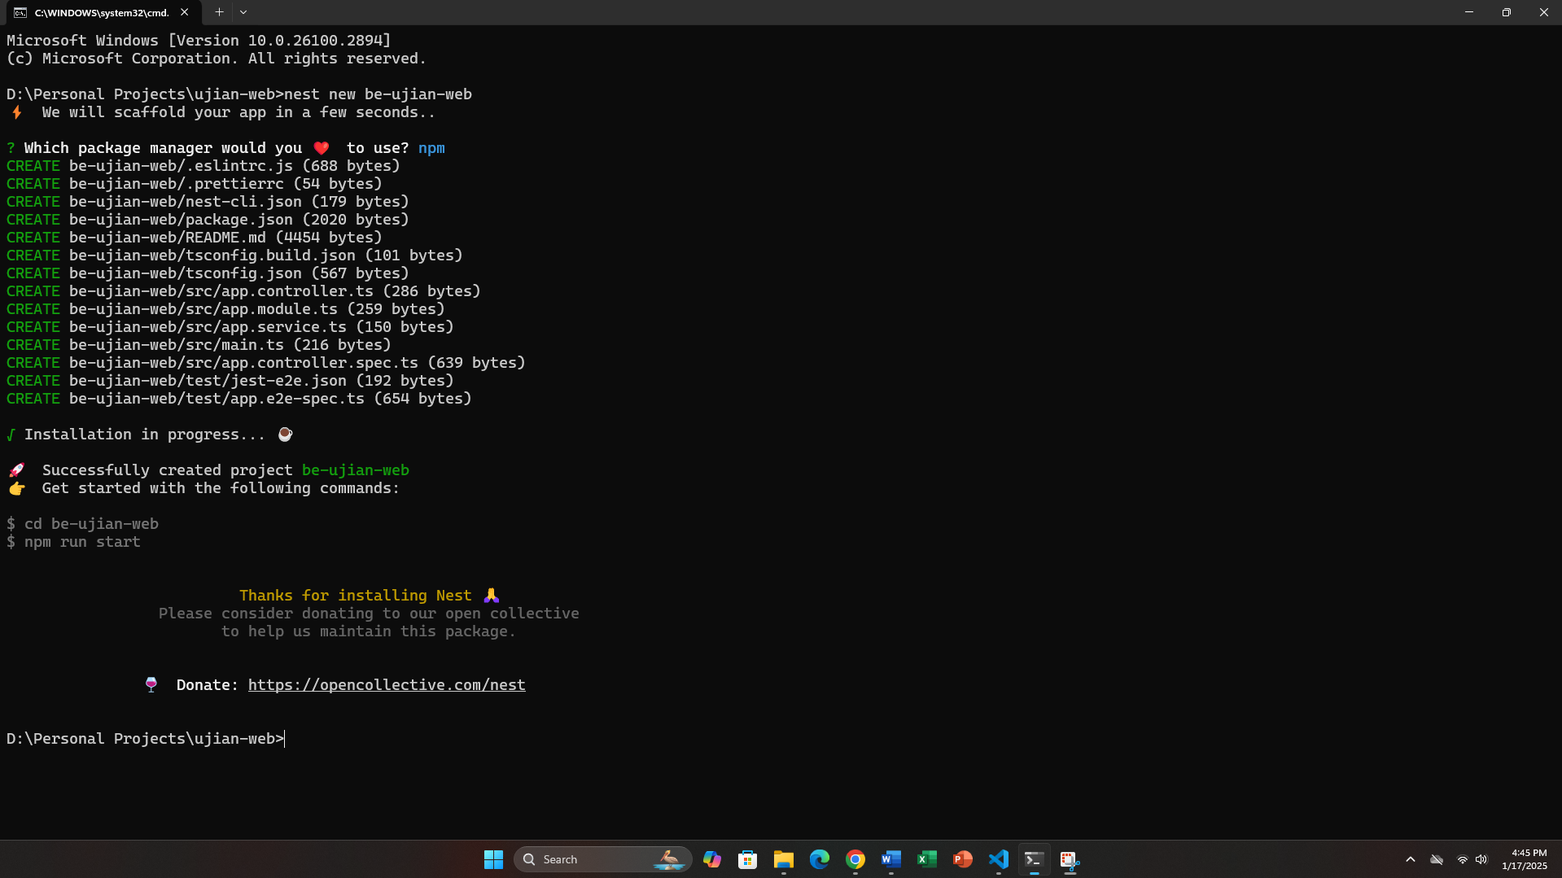

* Instalasi Prisma

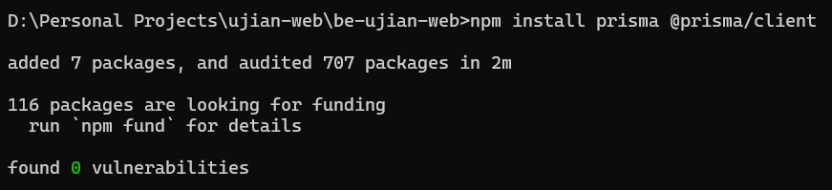

* Instalasi Cloudinary

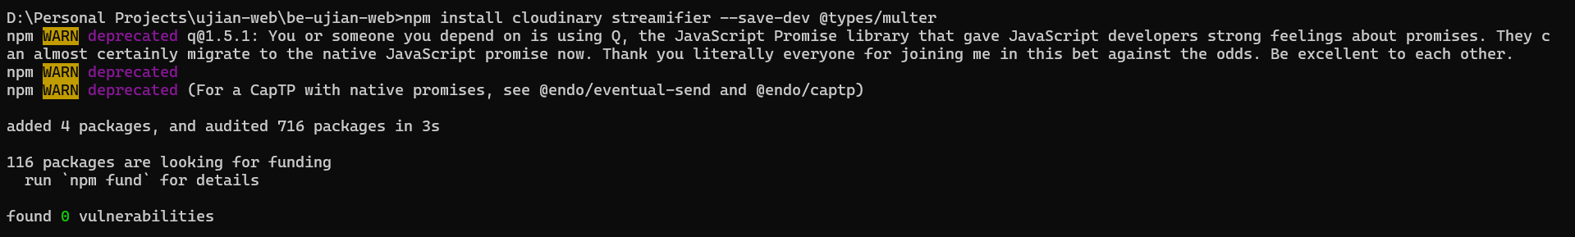

* Instalasi Class Validator dan Class Transformer

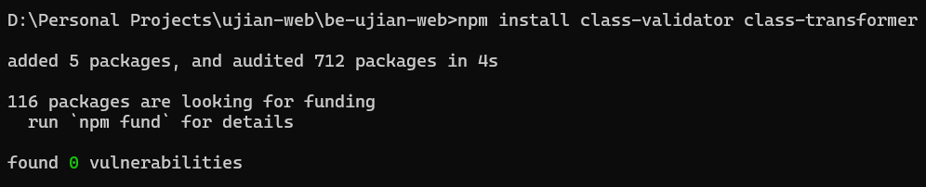

#### **3.2.2 Prisma Schema**

Prisma schema adalah inti dari pengelolaan database dalam proyek ini. Bagian ini menjelaskan bagaimana skema database dirancang.

* Schema Database Prisma

|  |
| --- |
| // This is your Prisma schema file,  // learn more about it in the docs: https://pris.ly/d/prisma-schema  // Looking for ways to speed up your queries, or scale easily with your serverless or edge functions?  // Try Prisma Accelerate: https://pris.ly/cli/accelerate-init  generator client {  provider = "prisma-client-js"  }  datasource db {  provider = "mongodb"  url = **env**("DATABASE_URL")  }  model **Dream** {  id **String** @id @default(**auto**()) @map("_id") @db.ObjectId  username **String**  title **String** @unique  slug **String**? @unique  description **String**  image **String**?  createdAt **DateTime** @default(**now**())  updatedAt **DateTime** @updatedAt  @@map("dreams")  } |

#### **3.2.3 Modules**

Modules adalah komponen utama dalam struktur NestJS yang membantu pengelolaan kode secara modular. Pada bagian ini, akan dijelaskan cara membagi fungsionalitas ke dalam modul-modul terpisah dan memastikan integrasi antar modul berjalan dengan baik.

* Cloudinary
* Cloudinary Response

|  |
| --- |
| **import** { **UploadApiErrorResponse**, **UploadApiResponse** } **from** 'cloudinary';  **export** **type** **CloudinaryResponse** = **UploadApiResponse** | **UploadApiErrorResponse**; |

* Cloudinary Provider

|  |
| --- |
| // cloudinary.provider.ts  **import** { v2 **as** cloudinary } **from** 'cloudinary';  **export** **const** **CloudinaryProvider** = {  provide: 'CLOUDINARY',  useFactory: () => {  **return** cloudinary.**config**({  cloud_name: `${process.env.CLOUDINARY_NAME}`,  api_key: `${process.env.CLOUDINARY_API_KEY}`,  api_secret: `${process.env.CLOUDINARY_API_SECRET}`,  });  },  }; |

* Cloudinary Module

|  |
| --- |
| **import** { **Module** } **from** '@nestjs/common';  **import** { **CloudinaryService** } **from** './cloudinary.service';  **import** { **CloudinaryProvider** } **from** './cloudinary/cloudinary.provider';  @Module({  providers: [**CloudinaryProvider**, **CloudinaryService**],  exports: [**CloudinaryProvider**, **CloudinaryService**],  })  **export** **class** **CloudinaryModule** {} |

* Cloudinary Service

|  |
| --- |
| **import** { **HttpException**, **Injectable** } **from** '@nestjs/common';  **import** { v2 **as** cloudinary } **from** 'cloudinary';  **import** { **CloudinaryResponse** } **from** './cloudinary/cloudinary-response';  **const** streamifier = require('streamifier');  @Injectable()  **export** **class** **CloudinaryService** {  **uploadFile**(  file: **Express**.Multer.File,  onlyImage: boolean,  ): **Promise**<**CloudinaryResponse**> {  **if** (!file) **throw** **new** **HttpException**('File not found!', 404);  **const** fileSizeLimit = 10 * 1024 * 1024;  **if** (file.size > fileSizeLimit)  **throw** **new** **HttpException**('File size exceeds 10 MB limit.', 400);  **const** allowedExtensions = ['jpeg', 'jpg', 'png', 'JPEG', 'JPG', 'PNG'];  **const** [fileType, fileExtension] = file.mimetype.**split**('/');  **if** (onlyImage === true)  **if** (!allowedExtensions.**includes**(fileExtension))  **throw** **new** **HttpException**(  'File type not supported. Only JPEG, JPG, and PNG files are allowed.',  400,  );  **return** **new** **Promise**<**CloudinaryResponse**>((resolve, reject) => {  **const** uploadStream = cloudinary.uploader.**upload_stream**(  { folder: 'DREAM-STATION' },  (error, result) => {  **if** (error) **return** **reject**(error);  **resolve**(result);  },  );  streamifier.**createReadStream**(file.buffer).**pipe**(uploadStream);  });  }  } |

* Dream
* Dream Controller

|  |
| --- |
| **import** {  **Body**,  **Controller**,  **Delete**,  **Get**,  **HttpException**,  **HttpStatus**,  **Param**,  **Patch**,  **Post**,  **Query**,  **UploadedFile**,  **UseInterceptors**,  } **from** '@nestjs/common';  **import** { **FileInterceptor** } **from** '@nestjs/platform-express';  **import** { **DreamsService** } **from** './dreams.service';  **import** { **QueryDreamsDto** } **from** './dtos/query-dreams.dto';  **import** { **CreateDreamDto** } **from** './dtos/create-dream.dto';  **import** { **PrismaService** } **from** '../prisma/prisma.service';  **import** { **CloudinaryService** } **from** '../cloudinary/cloudinary.service';  **import** { **UpdateDreamDto** } **from** './dtos/update-dream-dto';  **const** **slugify** = (title: string) => {  **return** title  .**toLowerCase**()  .**replace**(/\s+/g, '-')  .**replace**(/[^\w\-]+/g, '')  .**trim**();  };  @Controller('/api/dreams')  **export** **class** **DreamsController** {  **constructor**(  **private** dreamsService: DreamsService,  **private** prismaService: PrismaService,  **private** **readonly** cloudinaryService: CloudinaryService,  ) {}  @Get()  **getAllDreams**(@Query() query: QueryDreamsDto) {  **return** this.dreamsService.**getAllDreams**(query);  }  @Get('/:slug')  **async** **getDreamBySlug**(@Param('slug') slug: string) {  **const** category = **await** this.dreamsService.**getDreamBySlug**(slug);  **if** (!category) **throw** **new** **HttpException**('Dream not found!', 404);  **return** category;  }  @Post()  @UseInterceptors(**FileInterceptor**('image'))  **async** **createDream**(  @Body() body: CreateDreamDto,  @UploadedFile() image: Express.Multer.File,  ) {  **try** {  **const** slug = **slugify**(body.title);  **const** dream = **await** this.dreamsService.**getDreamBySlug**(slug);  **if** (dream)  **throw** **new** **HttpException**('Dream already exist!', **HttpStatus**.BAD_REQUEST);  **if** (image) {  **const** uploadedImage = **await** this.cloudinaryService.**uploadFile**(  image,  true,  );  body.image = uploadedImage.secure_url;  }  **return** this.dreamsService.**createDream**(body);  } **catch** (error) {  **throw** **new** **HttpException**(  error.message || 'Failed to create dream',  **HttpStatus**.BAD_REQUEST,  );  }  }  @Patch('/:slug')  @UseInterceptors(**FileInterceptor**('image'))  **async** **updateDreamBySlug**(  @Param('slug') slug: string,  @Body() body: UpdateDreamDto,  @UploadedFile() image: Express.Multer.File,  ) {  **try** {  **const** dream = **await** this.dreamsService.**getDreamBySlug**(slug);  **if** (!dream) **throw** **new** **HttpException**('Dream not found!', 404);  **if** (image) {  **const** uploadedImage = **await** this.cloudinaryService.**uploadFile**(  image,  true,  );  body.image = uploadedImage.secure_url;  }  **const** slugUpdate = **slugify**(body.title);  **return** this.dreamsService.**updateDreamBySlug**(slug, slugUpdate, body);  } **catch** (error) {  **throw** **new** **HttpException**(  error.message || 'Failed to update dream',  **HttpStatus**.BAD_REQUEST,  );  }  }  @Delete('/:slug')  **async** **deleteBlogBySlug**(@Param('slug') slug: string) {  **const** dream = **await** this.prismaService.dream.**findUnique**({  where: {  slug: slug,  },  });  **if** (!dream) **throw** **new** **HttpException**('Drea not found!', 404);  **return** this.dreamsService.**deleteDreamBySlug**(slug);  }  } |

* Dream Module

|  |
| --- |
| **import** { **Module** } **from** '@nestjs/common';  **import** { **DreamsService** } **from** './dreams.service';  **import** { **DreamsController** } **from** './dreams.controller';  **import** { **PrismaModule** } **from** '../prisma/prisma.module';  **import** { **CloudinaryModule** } **from** '../cloudinary/cloudinary.module';  @Module({  imports: [**PrismaModule**, **CloudinaryModule**],  providers: [**DreamsService**],  controllers: [**DreamsController**],  exports: [**DreamsService**],  })  **export** **class** **DreamsModule** {} |

* Dream Service

|  |
| --- |
| **import** { **HttpException**, **Injectable** } **from** '@nestjs/common';  **import** { **PrismaService** } **from** '../prisma/prisma.service';  **import** { **QueryDreamsDto** } **from** './dtos/query-dreams.dto';  **import** { **Prisma** } **from** '@prisma/client';  **const** **slugify** = (title: string) => {  **return** title  .**toLowerCase**()  .**replace**(/\s+/g, '-')  .**replace**(/[^\w\-]+/g, '')  .**trim**();  };  @Injectable()  **export** **class** **DreamsService** {  **constructor**(**private** prismaService: PrismaService) {}  **async** **getAllDreams**(query: QueryDreamsDto) {  **const** pgNum = +(query.pgNum ?? 1);  **const** pgSize = +(query.pgSize ?? 10);  **const** skip = (pgNum - 1) * pgSize;  **const** take = pgSize;  **const** where: **Prisma**.DreamWhereInput = {  ...(query.title && {  title: { contains: query.title, mode: 'insensitive' },  }),  };  **const** orderBy: **Prisma**.DreamOrderByWithAggregationInput =  query.sortOrder === 'newest'  ? { createdAt: 'desc' }  : query.sortOrder === 'oldest'  ? { createdAt: 'asc' }  : { createdAt: 'desc' };  **const** dreams = **await** this.prismaService.dream.**findMany**({  skip,  take,  where,  orderBy,  });  **const** dreamsCount = **await** this.prismaService.dream.**count**({ where });  **return** {  dreams,  meta: {  count: dreamsCount,  },  };  }  **getDreamBySlug**(slug: string) {  **return** this.prismaService.dream.**findUnique**({  where: {  slug,  },  });  }  **async** **createDream**(createDreamData: Prisma.DreamCreateInput) {  **const** slug = **slugify**(createDreamData.title);  **const** category = **await** this.**getDreamBySlug**(slug);  **if** (category) **throw** **new** **HttpException**('Dream already exist!', 401);  **return** this.prismaService.dream.**create**({  data: {  ...createDreamData,  slug,  },  });  }  **updateDreamBySlug**(  slug: string,  slugUpdate: string,  updateDreamByIdData: Prisma.DreamUpdateInput,  ) {  **return** this.prismaService.dream.**update**({  where: {  slug,  },  data: {  ...updateDreamByIdData,  slug: slugUpdate,  },  });  }  **async** **deleteDreamBySlug**(slug: string) {  **await** this.prismaService.dream.**delete**({  where: {  slug,  },  });  **return** {  message: 'Successfully delete the dream!',  statusCode: 200,  };  }  } |

* Create Dream DTO

|  |
| --- |
| **import** {  **IsOptional**,  **IsString**,  **IsUrl**,  **IsNotEmpty**,  **MinLength**,  **MaxLength**,  } **from** 'class-validator';  **export** **class** **CreateDreamDto** {  @IsString({ message: 'Username must be a string' })  @IsNotEmpty({ message: 'Username cannot be empty' })  @MinLength(1, { message: 'Username must be at least 1 character long' })  @MaxLength(50, { message: 'Username cannot exceed 50 characters' })  username: string;  @IsString({ message: 'Title must be a string' })  @IsNotEmpty({ message: 'Title cannot be empty' })  @MinLength(1, { message: 'Title must be at least 1 character long' })  @MaxLength(50, { message: 'Title cannot exceed 50 characters' })  title: string;  @IsString({ message: 'Description must be a string' })  @IsNotEmpty({ message: 'Description cannot be empty' })  @MinLength(1, { message: 'Description must be at least 1 character long' })  @MaxLength(150, { message: 'Description cannot exceed 150 characters' })  description: string;  @IsOptional()  @IsUrl({}, { message: 'Image must be a valid URL' })  image?: string;  } |

* Query Dream DTO

|  |
| --- |
| **import** { **IsOptional**, **IsString** } **from** 'class-validator';  **export** **class** **QueryDreamsDto** {  @IsOptional()  @IsString()  title?: string;  @IsString()  @IsOptional()  sortOrder?: 'newest' | 'oldest';  @IsString()  @IsOptional()  pgNum?: string;  @IsString()  @IsOptional()  pgSize?: string;  } |

* Update Dream DTO

|  |
| --- |
| **import** {  **IsOptional**,  **IsString**,  **MinLength**,  **MaxLength**,  **IsUrl**,  } **from** 'class-validator';  **export** **class** **UpdateDreamDto** {  @IsOptional()  @IsString({ message: 'Username must be a string' })  @MinLength(1, { message: 'Username must be at least 1 character long' })  @MaxLength(50, { message: 'Username cannot exceed 50 characters' })  username?: string;  @IsOptional()  @IsString({ message: 'Title must be a string' })  @MinLength(1, { message: 'Title must be at least 1 character long' })  @MaxLength(50, { message: 'Title cannot exceed 50 characters' })  title?: string;  @IsOptional()  @IsString({ message: 'Description must be a string' })  @MinLength(1, { message: 'Description must be at least 1 character long' })  @MaxLength(150, { message: 'Description cannot exceed 150 characters' })  description?: string;  @IsOptional()  @IsUrl({}, { message: 'Image must be a valid URL' })  image?: string;  } |

* Prisma
* Prisma Module

|  |
| --- |
| **import** { **Module** } **from** '@nestjs/common';  **import** { **PrismaService** } **from** './prisma.service';  @Module({  providers: [**PrismaService**],  exports: [**PrismaService**],  })  **export** **class** **PrismaModule** {} |

* Prisma Service

|  |
| --- |
| **import** { **Injectable**, **OnModuleInit** } **from** '@nestjs/common';  **import** { **PrismaClient** } **from** '@prisma/client';  @Injectable()  **export** **class** **PrismaService** **extends** **PrismaClient** **implements** **OnModuleInit** {  **onModuleInit**() {  this.$connect()  .**then**(() => console.**log**('Connected to DB with Prisma!'))  .**catch**((err) => {  console.**log**(err);  });  }  } |

### **3.3 Output**

Output merupakan hasil akhir dari sistem yang telah dirancang dan dikembangkan. Bagian ini akan menjelaskan bagaimana data yang telah diinput oleh pengguna ditampilkan kembali melalui antarmuka pengguna, serta bagaimana informasi tersebut dapat dimanfaatkan untuk mencapai tujuan website. Penjelasan ini mencakup visualisasi mimpi yang dibagikan, format tampilan, dan bagaimana data tersebut memberikan motivasi kepada pengguna lain.

* Landing

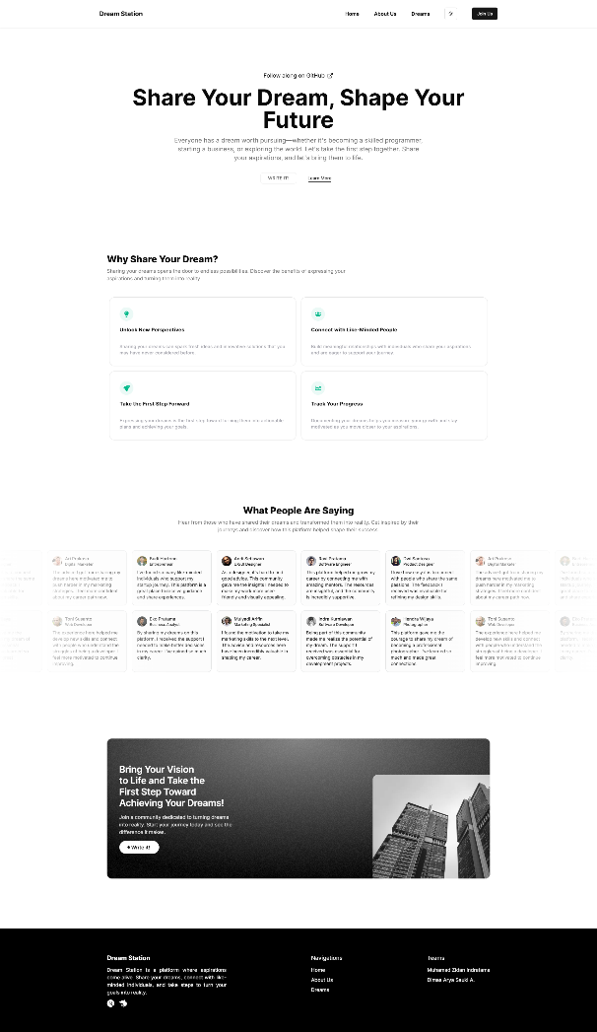

* About Us

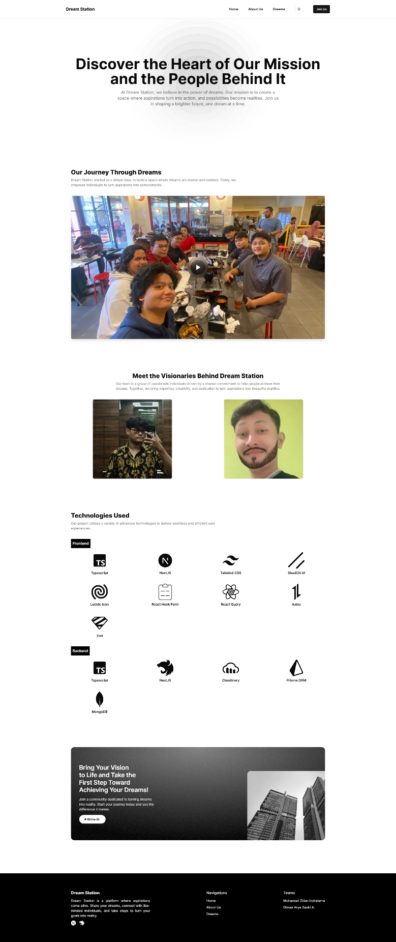

* Dreams

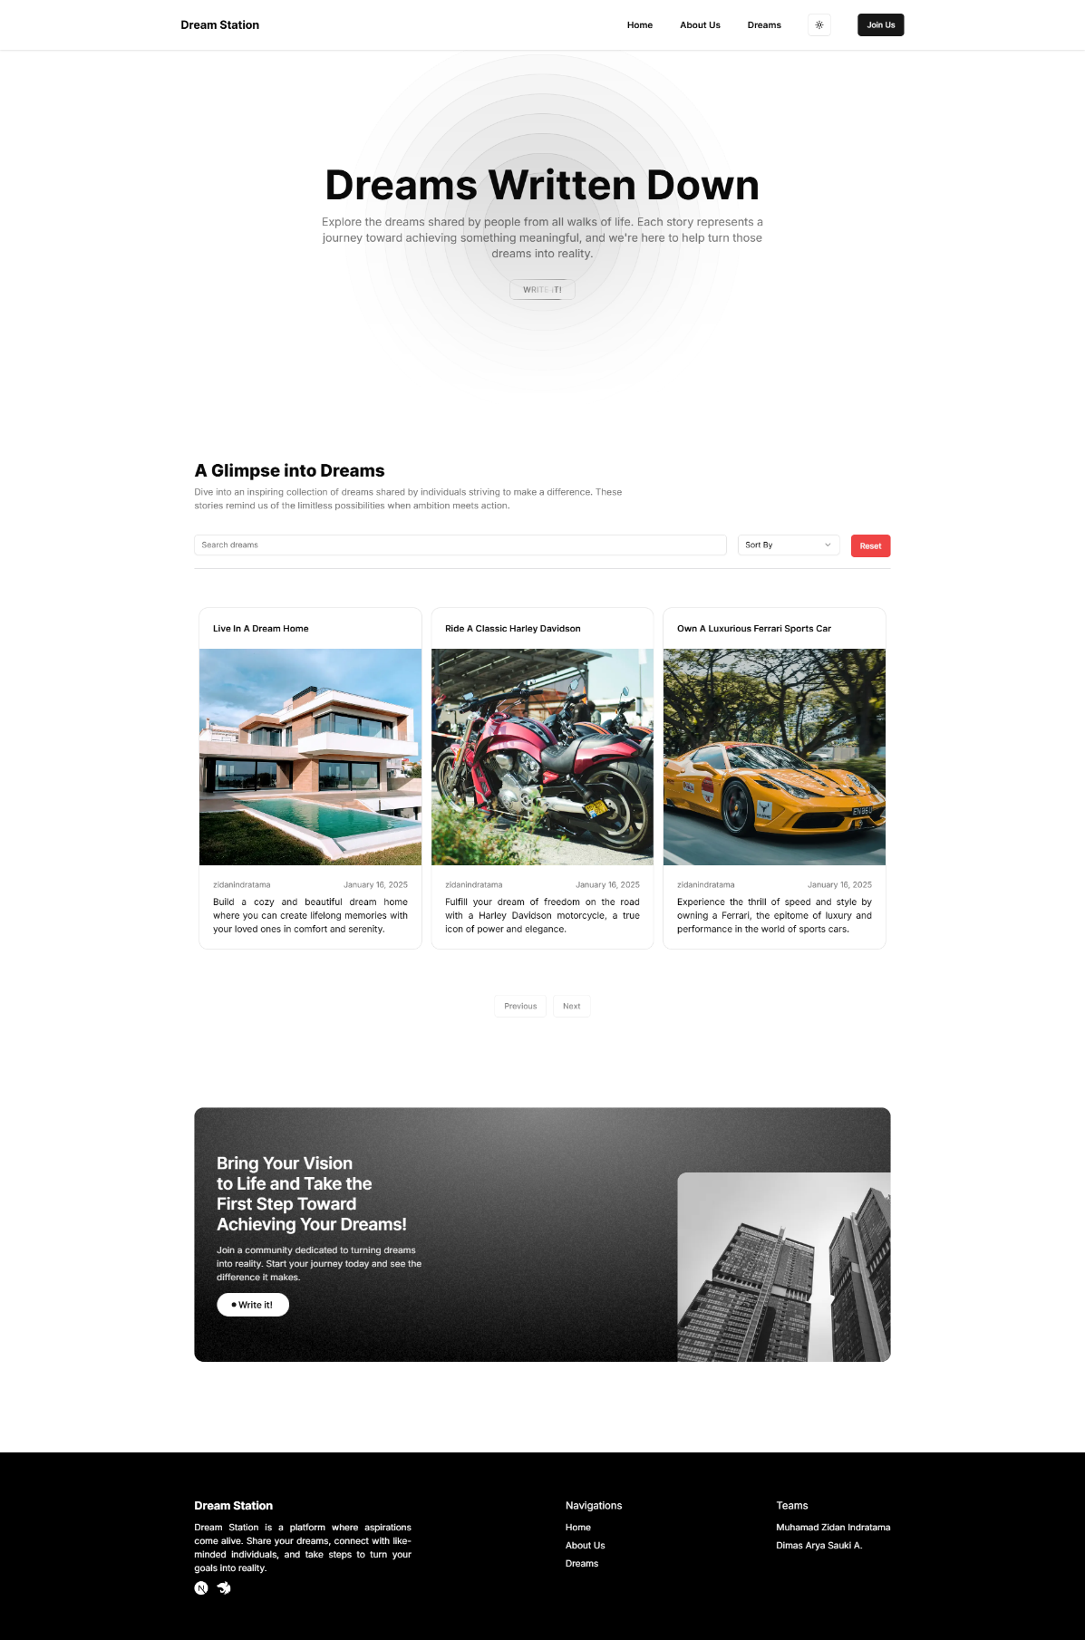

* Dream Create

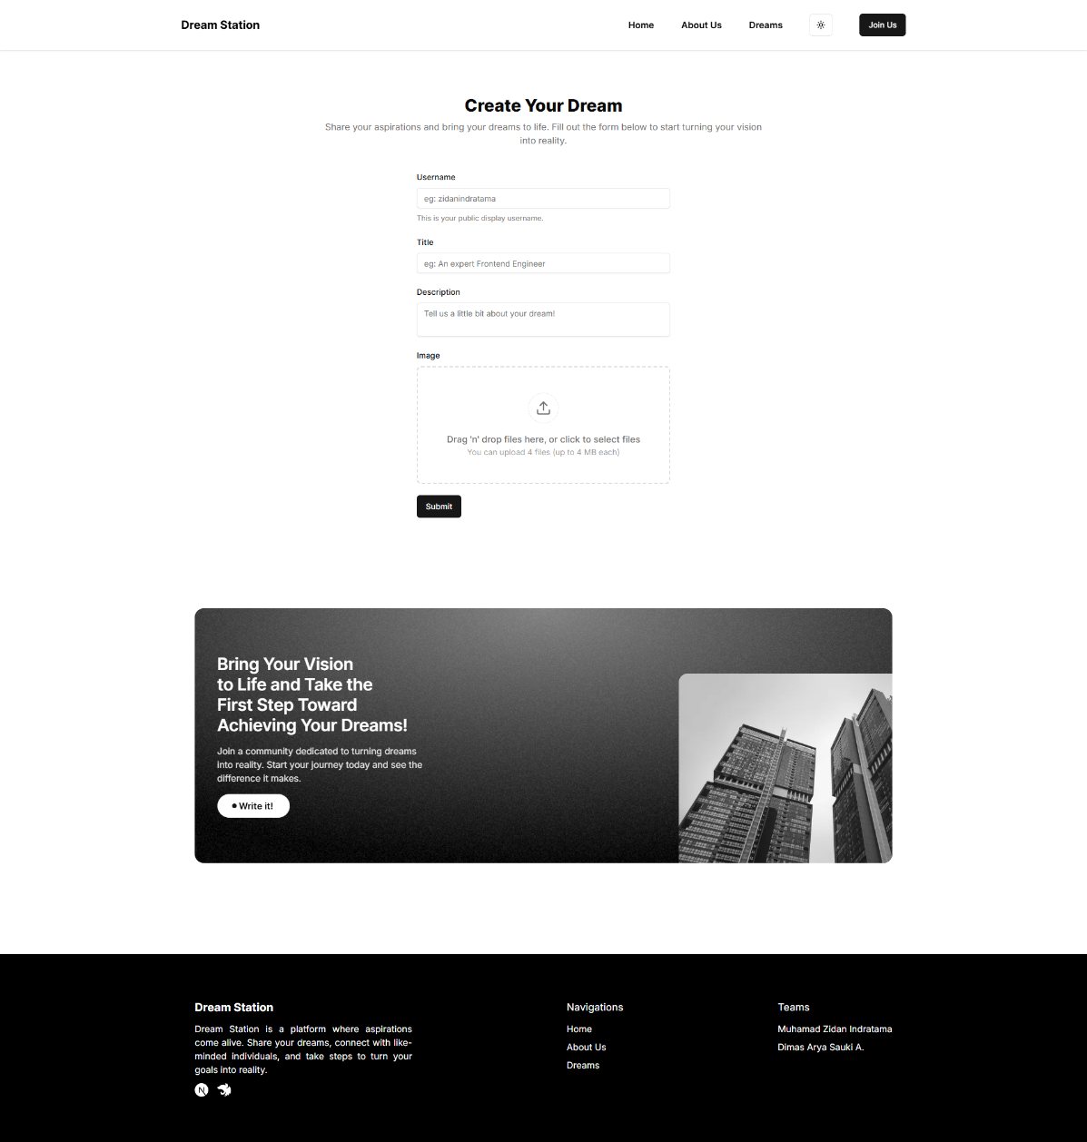

* Dream Update

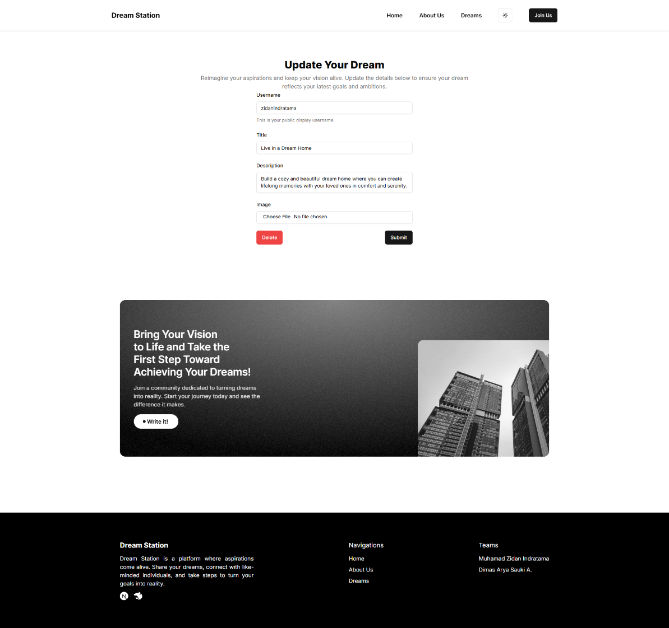

### **3.4 Link**

* Front-end

<https://fe-ujian-pemrograman-web.vercel.app>

* Back-end

https://be-ujian-pemrograman-web.vercel.app

# **BAB IV**

## **PENUTUP**

### **4.1 Kesimpulan**

Dalam proyek ini, telah dirancang dan dikembangkan sebuah website yang memungkinkan pengguna untuk mencatat, membagikan, dan melihat mimpi-mimpi dari pengguna lain. Dengan memanfaatkan teknologi modern baik di sisi frontend maupun backend, website ini tidak hanya memberikan pengalaman pengguna yang optimal tetapi juga mampu menjadi media motivasi yang inspiratif.

Melalui fitur pencatatan mimpi, berbagi motivasi, dan komunitas yang saling mendukung, platform ini bertujuan untuk mengingatkan pengguna akan mimpi mereka serta membangun semangat bersama untuk meraih tujuan hidup. Pemanfaatan teknologi seperti NextJS, TailwindCSS, NestJS, dan Prisma menjadikan sistem ini responsif, aman, dan terstruktur dengan baik.

Dengan platform ini, diharapkan pengguna tidak hanya mampu mengingat mimpi mereka, tetapi juga terinspirasi untuk terus berusaha dan mendukung orang lain dalam perjalanan mencapai mimpi tersebut.

### **4.2 Saran**

Untuk pengembangan lebih lanjut, berikut beberapa saran yang dapat dipertimbangkan:

1. Pengembangan Fitur Tambahan

Untuk meningkatkan nilai dan manfaat platform ini, pengembang dapat mempertimbangkan penambahan fitur seperti notifikasi pengingat, sistem komentar atau dukungan antar pengguna, serta gamifikasi untuk meningkatkan keterlibatan pengguna.

1. Optimisasi Performansi

Sebaiknya dilakukan pengujian berkala untuk memastikan performansi website tetap optimal, terutama jika jumlah pengguna dan data meningkat.

1. Peningkatan Keamanan

Pengamanan data pengguna dapat terus ditingkatkan dengan menambahkan fitur seperti autentikasi dua faktor atau enkripsi data.

1. Kolaborasi dengan Komunitas

Mengintegrasikan platform dengan komunitas atau organisasi terkait dapat membantu memperluas jangkauan pengguna dan menciptakan dampak yang lebih besar.

Dengan melanjutkan pengembangan dan perbaikan, platform ini memiliki potensi besar untuk menjadi alat yang bermanfaat bagi banyak orang dalam mewujudkan mimpi mereka.